ASTRO CLICKER 2



12 / 26 / 2023

Version 1.0

GAME DEV PROJECT

CREDITS

**LEAD DESIGNER** - bangarang1455

**LEAD DEVELOPER** -

MARKETING

Delivery Date

Target is End of January 2024 or start of January 2024, not a big scale project.

Sites of Distribution

The Game will be distributed in free game sites such as itch.io, Newgrounds.com, Armorgames, Kongregate, GameJolt, CrazyGames, Steam, ClickerGamesLike, etc.

Genre

Sci-fi Clicker that involves tactical decisions based on Clicks.

Category

Clicker Idle

Similar Titles

Clicker Heroes, Crystalien Conflict, MyLEGONetwork, ZombIdle.

Setting

The Outer Space, where the player mines crystals on a planet.

Look

Third Person View With 2D Sprites Cartoon PNG IMAGES.

High Concept

The High Concept of the game is that the game is a Clicker-Idle game in which the player is constantly mining and hooked with the gameplay as the player is trying to get all the achievements, upgradables, badges and of course Mining and transforming the scorching planet known as “The Last Planet” which will mean the END of the game.

Plot

The Plot is that the player is in outer space hired by the Space Mining Agency to mine as many crystals and discover new planets in search of more of those crystals. But one Secret Mission has been ordered by the High Chain of Command… to Find the Last Planet… that is where the Last Satellite was found, the player must repair it, and that would be the end of the mission. Where the player can terraform the Planet and get a big amount of crystals from there.

Competitive Analysis

* Ascend to other Planets
* Different color of crystals per planet
* Find the Last Planet
* Terraforming the Last Planet
* Aliens Attacking Challenges
* 10 Upgrades with different DPS and unique skills.
* Craftable Badges and Achieve itments

Technology Used in the Dev

**Operating System**: Windows 10

**Characters:** 2D Sprites

**Creatures:** 2D Sprites

**Surrounding:** 2D Sprites

**Structures:** 2D Sprites

**Vehicles:** 2D Sprites

**Interface:** 2D Sprites

System Requirements

Operating System: Windows 7/8/10 (64-bit)

Processor: Intel Core i3 / AMD Ryzen 3 or equivalent

Memory: 4 GB RAM

Graphics: DirectX 11 compatible graphics card with 1 GB VRAM

DirectX: Version 11

Storage: 10 GB available space

Sound Card: DirectX compatible

GAME FLOW

First Splash Screen - Publisher

Small Fade in and Fade Out Logo animation of Newgrounds or the Website in which we publish, so Kongregate when we publish in Kongregate and so on the others… Newgrounds, Armorgames,etc.

Second Splash Screen - Developers

We put our usernames in there.

Introductory Cinematic

Black Screen with text saying “Take off in 3, 2, 1…” WHITE FLASH and then BOOM we go to the Main Menu.

Main Menu

A simple 2D screen.appears listing the following options:

• New Game

• Load Saved Game

• Achievements

• Options (PC settings)

SCENE OVERVIEW

Setting

It will be a black screen in outer space with a Space Shuttle on the corner and the Planet at the center of the map. The Crystals will be displayed just as the first game, which will be in the middle.

Scene Layout

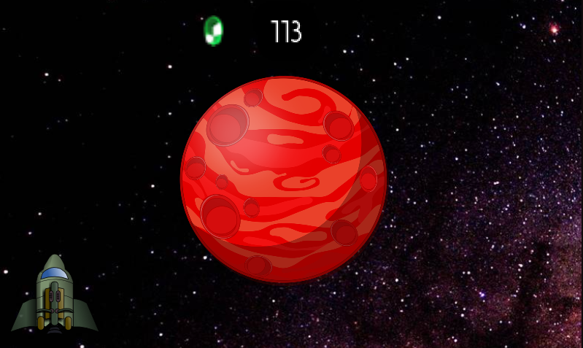

Link to the First Game to see all the Scene Layout in detail: [**https://www.newgrounds.com/portal/view/819084**](https://www.newgrounds.com/portal/view/819084)

UPGRADABLES

We will grab the first 10 upgradeables from the First Game, plus…

**SpaceStation** - For Unlocking New Troops and Intergalactic Travel.

Details: THE PLAYER CAN’T TRAVEL TO OTHER PLANETS IF IT DOESN’T HAVE THE SPACE STATION AND STUFF

**Research Lab** - For Unlocking New Technology

Details:

**"Quantum Spacetime Resilience Field Generator"> Unlocks the ability to travel inside black holes.**

Details:

**"Stellar Temporal Time Accelerator"> Unlocks the ability to change the time-phase for the Blue Dwarf to Black Dwarf. MUST HAVE TERRAFORMING DEVICE FIRST.**

Details:

**"Celestial Hazard Mastery"> Unlocks the ability to access the Blue Dwarfs and get bonuses for the game.**

Details:

**"Mini Black Hole Generator"> Unlocks the ability to generate up to 3 mini Black Holes at once**

Details:

**"Astro Field"> Unlocks the ability to double the amount of crystals per second by using a Field Satellite to lockdown the Crystals in the orbit of a planet.**

**BlackHole** - For destroying Alien UFO’s stealing Crystals

Details: When the black hole is acquired the player would add Blackholes as an attack for aliens and possibly for intergalactic travel if the player has the research tree.

**Terraforming Device… For Restoring Scorching Planets.**

Details:So when the player buys the terraforming device there should be an icon at the side of the space shuttle **TERRAFORMING DEVICE:** that when the player clicks it, he can click on the planet and terraform it. But It should only be re-buyable but with double the amount exponentially each time the player wants to buy it. So for example the first cost for the Terraforming device is 5000 then the second one is 25 million crystals and so on. Cuz it's 5000^2 and then 5000^3 and then 5000^4 and so on. THIS IS FOR THE TERRAFORMING DEVICE

A.I.M - Weapon (Sniper Rifle for shooting UFO’s)

There will be a total of X Upgradables…

DISCLAIMER: Upgradeables can be subject to change as well… this is not a final product…

ALIEN ATTACKS

**ALIEN UFO'S:** ok so the aliens should steal for 30 seconds, we can add the values later for the crystals, but they should steal 1/3 of the CRYSTALS PER SECOND, for example if the player is winning 100 crystals per second because of the unlockables he has, EACH ALIEN would steal 33 crystals per second. When the 30 seconds passed by the 3 Alien UFO's would float outta the screen. The idea is to make more challenging the attack, for each planet traveled, the attack exponentiates times 3, so for 3 planets traveled the player would have 9 UFO’s attacking in the 30 seconds. Possibly emptying the crystals of the player if he is careless. BUT THE PLAYER WOULD RECIEVE A BIGGER REWARD WHEN KILLING THE ALIENS, A X2 bonus for killing the aliens that gets bigger with each difficulty enhanced.   
  
 THE PLAYER COULD CLICK AND KILL THE ALIENS BUT IT’LL BE TOO MUCH SINCE THERE WOULD BE A LOT OF ALIENS IN THE SCREEN.

-----------------------------

STARS - SUN & BLUE DWARF

Stars in the game are very important. Celestial bodies will help the player get bonus 2X for the crystals they are getting. These celestials have the ability to infuse the crystals with a nuclear energy that makes different types of crystals that are not acquirable anywhere in the galaxy nor the universe.

We have a SET of 2 type of stars but Imma be very specific in this…

THE SUN - A shiny big star that the player can use for infusing crystals and gaining bonuses.

THE BLUE DWARF (6 phases) - A BIG star that the player can use for getting new types of crystals. The star has 6 phases to get new different types of crystals and better bonuses for each phase. The phases are in different colors starting with Blue, White, Yellow, Orange, Red, and finally BLACK which are the most rare to find.

THE BIG NOTE - Stars can appear randomly, it can be the next planet the player moves. But the player needs to have the Research of the Celestial Hazard Mastery in order to acquire crystals from these celestial bodies, even the sun. If the player MOVES TO THE SUN or red dwarf without the Celestial Hazard Mastery Research, they will burn and lose half the crystals they have and return to the last planet they were. Now the next planet they go to will be another randomly selected.

CELESTIAL STARS COME VERY RARE - they are stars that are light years into the future. That means they are hard to find even amongst the most rugged players. Now to be precise a sun is relatively easy to find, but to come across a blue dwarf is one in a thousand, imagine what would be

MARVEL PIECES

-------------------------------- **The Golden Planet:** Requirements: ***11 Terraformed Planets...******White crystals****: 10,000* ***Purple crystals****: 450,000* ***Orange crystals****: 670,000* ***Blue crystals****: 800,000* ***Green crystals****: 1,000,000* --------------------------------

**The Golden Alien:** Requirements:

**500 Killed Aliens...**

**White crystals**: 30,000 **Purple crystals**: 1,350,000 **Orange crystals**: 2,010,000 **Blue crystals**: 2,400,000 **Green crystals**: 3,000,000  
-------------------------------------------

**Super Space Shuttle** **Unlock 4/5 Research Lab Upgrades** **White crystals:** 270,000 **Purple crystals:** 12,150,000 **Orange crystals:** 18,090,000 **Blue crystals:** 21,600,000 **Green crystals:** 27,000,000*

-------------------------------------------  
 **Galaxy** Travel to the center of the galaxy (400 planets) **White crystals:** 4,050,000 **Purple crystals:** 182,250,000 **Orange crystals**: 271,350,000 **Blue crystals:** 324,000,000 **Green crystals:** 405,000,000

------------------------------

**Black Hole** **Unlock the "Quantum Spacetime Resilience Field Generator" (QSRFG) on the Research Lab and Travel 1000 Planets...** **White crystals:** 121,500,000 **Purple crystals:** 5,467,500,000 **Orange crystals:** 8,140,500,000 **Blue crystals:** 9,720,000,000 **Green crystals:** 12,150,000,000

------------------------------------

***TABS FOR THE SPACE SHUTTLE ICON*** Now it would be great if you can make a 2 tabs similar to those on the Supernova Icon that you did. Make 2 tabs that when you click on the Space shuttle the one thats on the left.... there should be the ***UPGRADABLES TAB***, then the ***INVENTORY TAB***, and then the............... ***STATS TAB***

* + - Green Crystals Acquired:
    - Blue Crystals Acquired:
    - Purple Crystals Acquired:
    - Orange Crystals Acquired:
    - White Crystals Acquired:
    - Total Crystals Acquired:
    - Terraformed Planets:
    - Marvel Pieces Acquired:
    - Achievements Acquired:
    - Planets Travelled:
    - Aliens Killed:
    - ????????????????????? (Easter Egg for the supernova) How many galaxies destroyed...

END GAME

The game will be set when the player has ascended to the Last Planet and terraformed it. From there he will unlock the “Last One” achievement for Unlocking the Last Planet and restoring it to its past glory.

Now the player can ascend to the Next Galaxy and commence a new game… where he can do the whole process again and finally get the “Galaxy Far Far Away” achievement for ascending to another galaxy.